FYP Emma meeting notes

Meeting 03/10

* FYP proposal, mental wellness website, access through phone
* Job ads, list jobs requirements
* Comp systems, coding + creative CSS
* Coop
* Figma, prototyping, medical devices regulation
* FYP fill gaps in your CV, adds to your portfolio
* GitHub, best practice

Plan FYP Report

Personal statement

Intro

* Overview, motivation
* Scope: narrow down to the framework of a FYP
  + (actually implemented)
* Goals and purpose

Research questions

* RQ 1 (lit rev)
* RQ 2 (existing)
* RQ 3 (development)
* RQ 4 (data)

Methods

* 1
* 2
* 3
* 4

Analysis of the existing

* Lit review
* Existing apps and devices (empirical, objective)
  + Objective: learn/apply skills, and/or fill a gap
  + Inclusion criteria: e.g. 5 top apps
  + List features, customer reviews (publicly available)
  + Screenshots
  + Table of Summary of features

Prototyping and product design development

* Priorities (gap, user validation)
* Design specifications
  + Must have = evidence-based, decision-making
  + From related apps
* Early sketches, low fid (paper), med (wireframe, Figma), iterations

User research

* Prototype testing, every step, 5 participants per design cycle
* Lessons learned, design decisions, user feedback

Discussions

* Have you responded to RQ

Conclusions

Appendix

* Info sheet + consent form
* Data, transcripts
* Tutorials
* Version control – screenshots of code or GitHub
* Screenshots and pictures of sketches

[Design Sprints - the Google Way](https://www.designsprint.academy/blog/googles-design-sprint-evolution-a-deep-dive-into-their-methodology)

[S&E Research Ethics | University of Limerick](https://www.ul.ie/scieng/scieng-research/research-ethics)

* Wouldn’t let me ‘Click or Tap to Enter Dates’ on pages 5 and 14.

**Job Ads and Requirements**

Microsoft – System Software Engineer

<https://www.linkedin.com/jobs/search/?currentJobId=4275647718&originalSubdomain=ie>

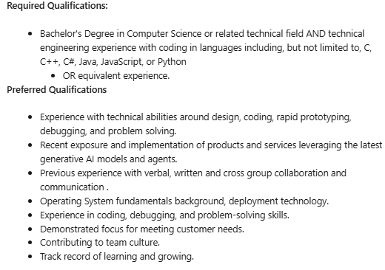

Meta – Network Production Engineer

<https://www.linkedin.com/jobs/search/?currentJobId=4309229550&geoId=104738515&keywords=computer%20science%20medica%3B&origin=JOB_SEARCH_PAGE_SEARCH_BUTTON&originalSubdomain=ie&refresh=true>

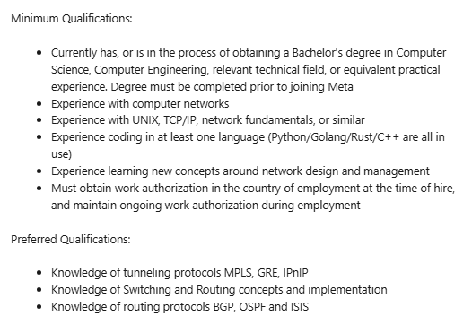

RedFaire - Graduate IT Consultant

<https://ie.indeed.com/q-computer-science-graduate-jobs.html?vjk=5e23e272d36e449a&advn=8568827198035720>

**Qualifications & Previous Experience:**

· Education: Bachelor’s degree in, Computer Science, Business Information Systems, Accounting, Information Technology, Supply Chain, or related discipline.

· Experience: 0–2 years of experience in IT consulting, ERP systems, or business process roles (internships or academic projects also considered).

· Soft Skills: Excellent communication, teamwork, and client-facing skills.  
Strong work Ethic, Proactive learner with an active interest in technology-enabled business transformation.

· Business acumen: Candidates should have a good understanding and curiosity of core business processes (Finance, Procurement, Supply Chain), and the ability to connect operational needs to system functionality.

· Analytical & Technical Skills: Strong analytical and problem-solving abilities with keen attention to detail.  
Familiarity with Microsoft Excel (pivot tables, lookups), PowerPoint and Word for documentation. Understanding of databases or data flow (conceptual) is advantageous, as is exposure to tools such as Power BI, SQL, or data visualization.

· A strong team player with the ability to collaborate effectively in a remote working environment, demonstrating initiative, clear communication, and accountability.

Dun & Bradstreet – Graduate Software Engineer

<https://www.glassdoor.ie/Job/ireland-computer-science-graduate-jobs-SRCH_IL.0,7_IN70_KO8,33.htm>

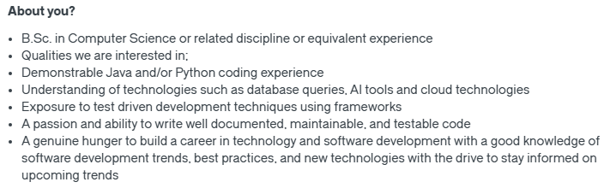

Kneat – Graduate Programme

<https://www.glassdoor.ie/Job/ireland-computer-science-graduate-jobs-SRCH_IL.0,7_IN70_KO8,33.htm>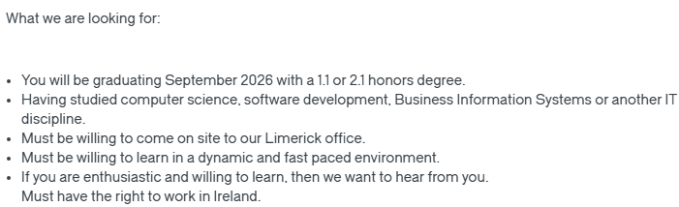

**Exisiting Apps + Feature Table**

1. Headspace  
Mostly audio features and videos

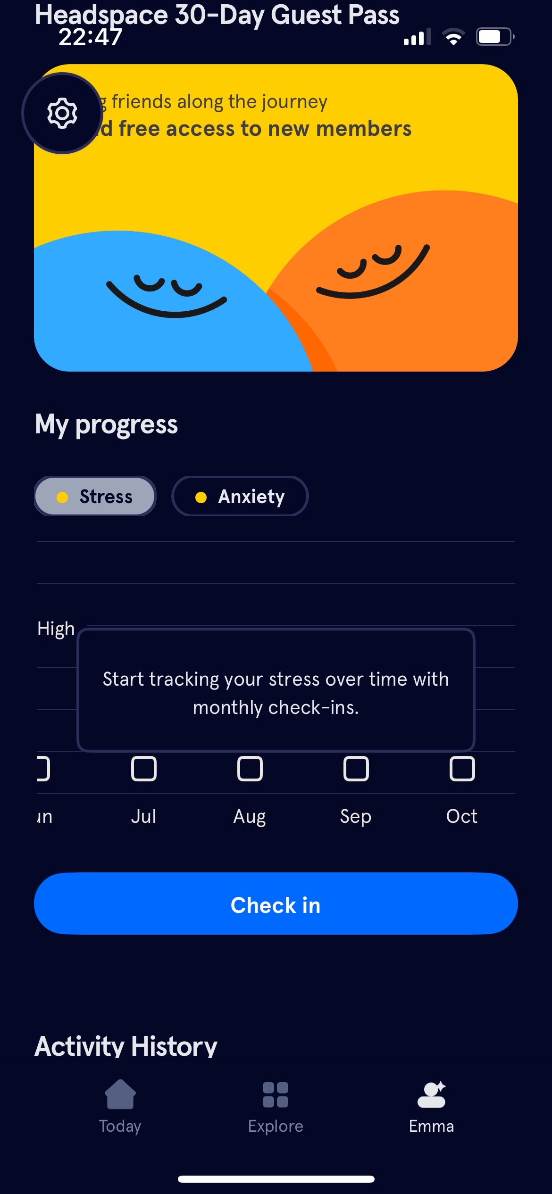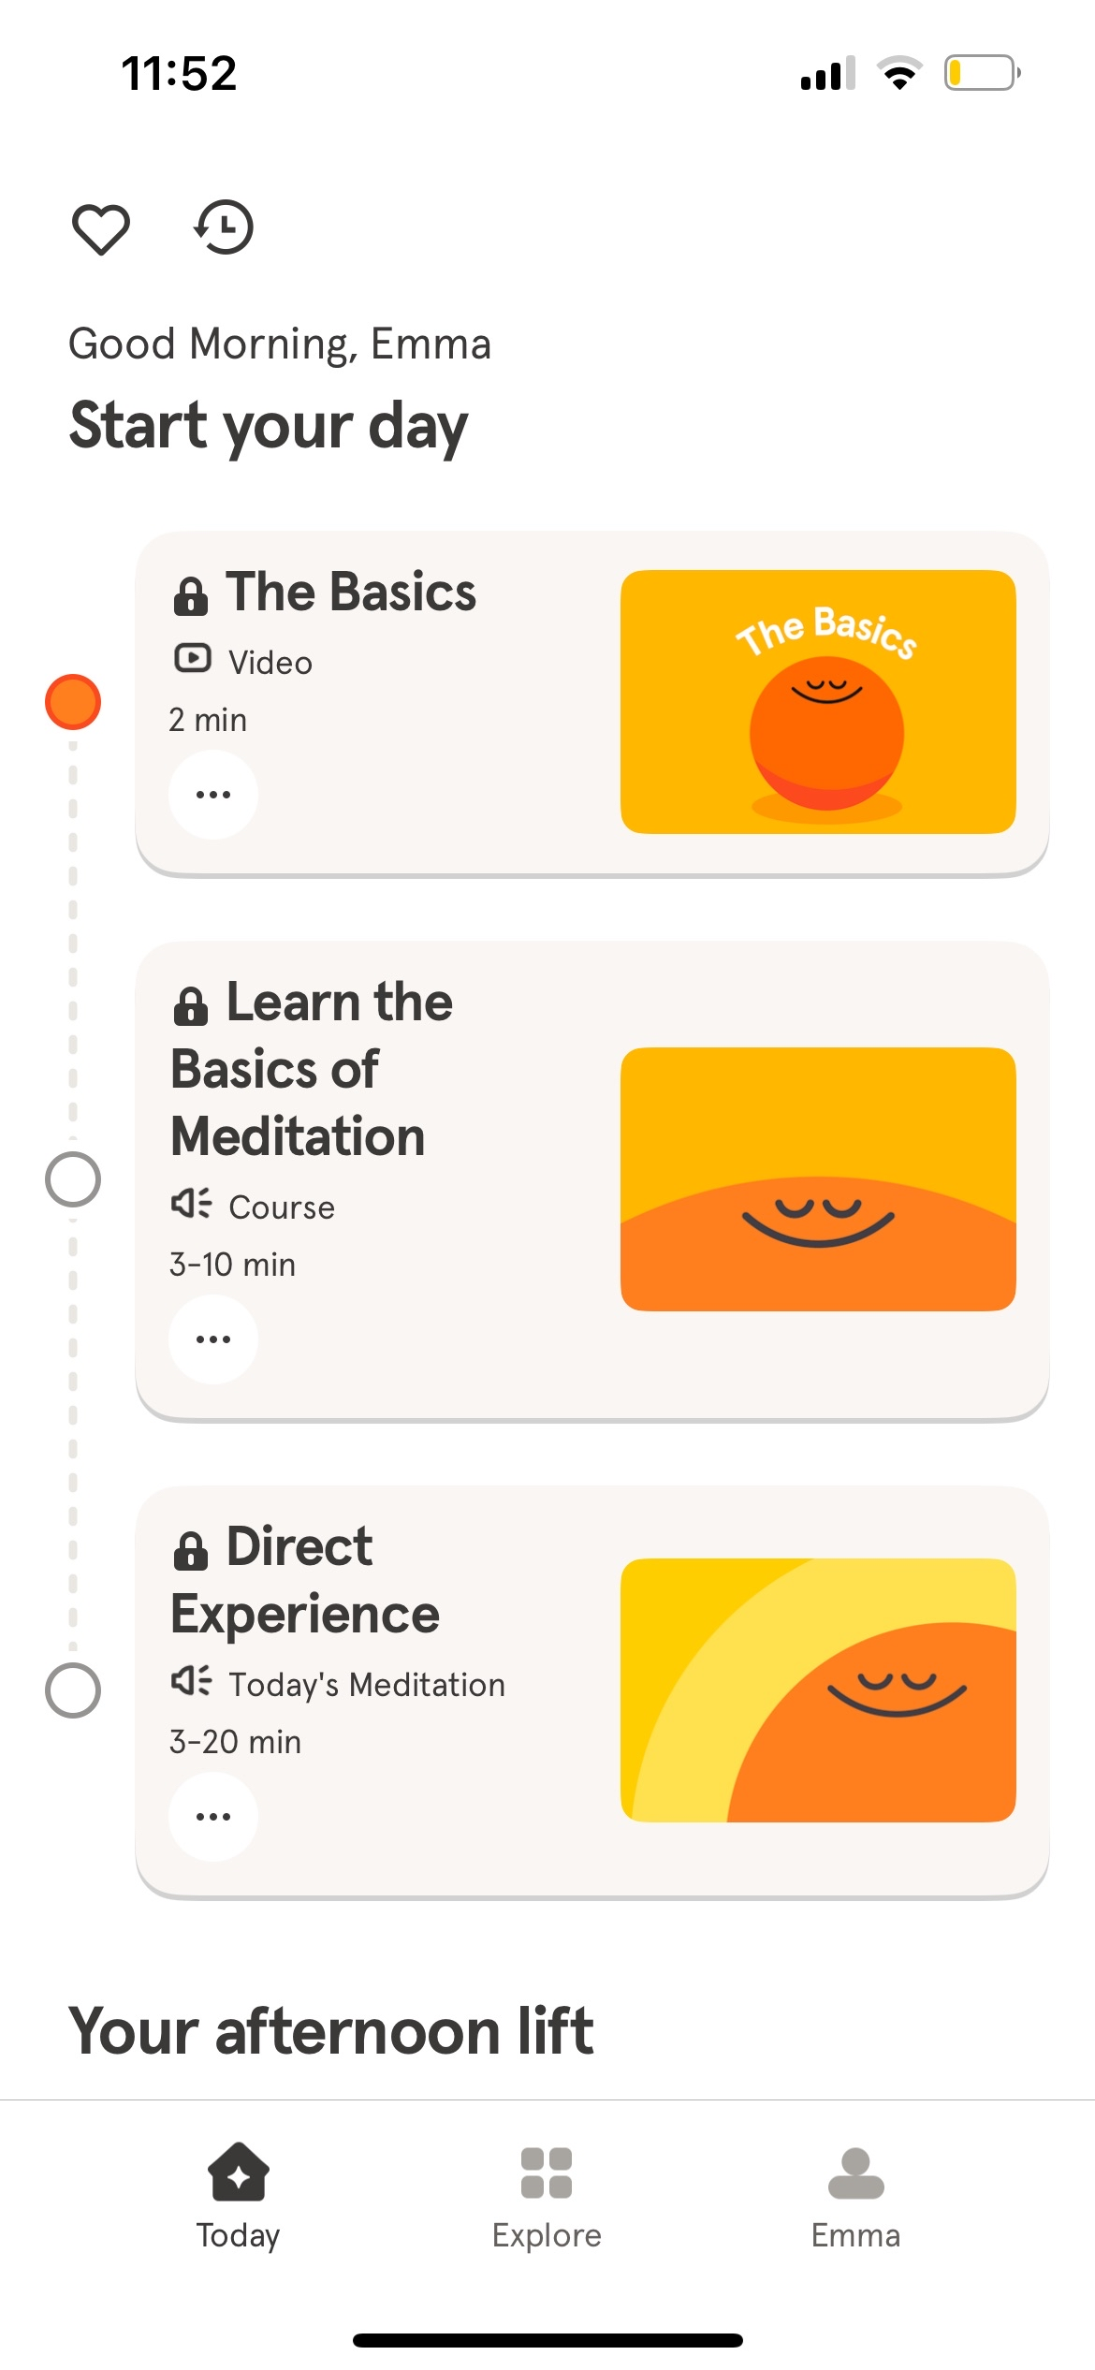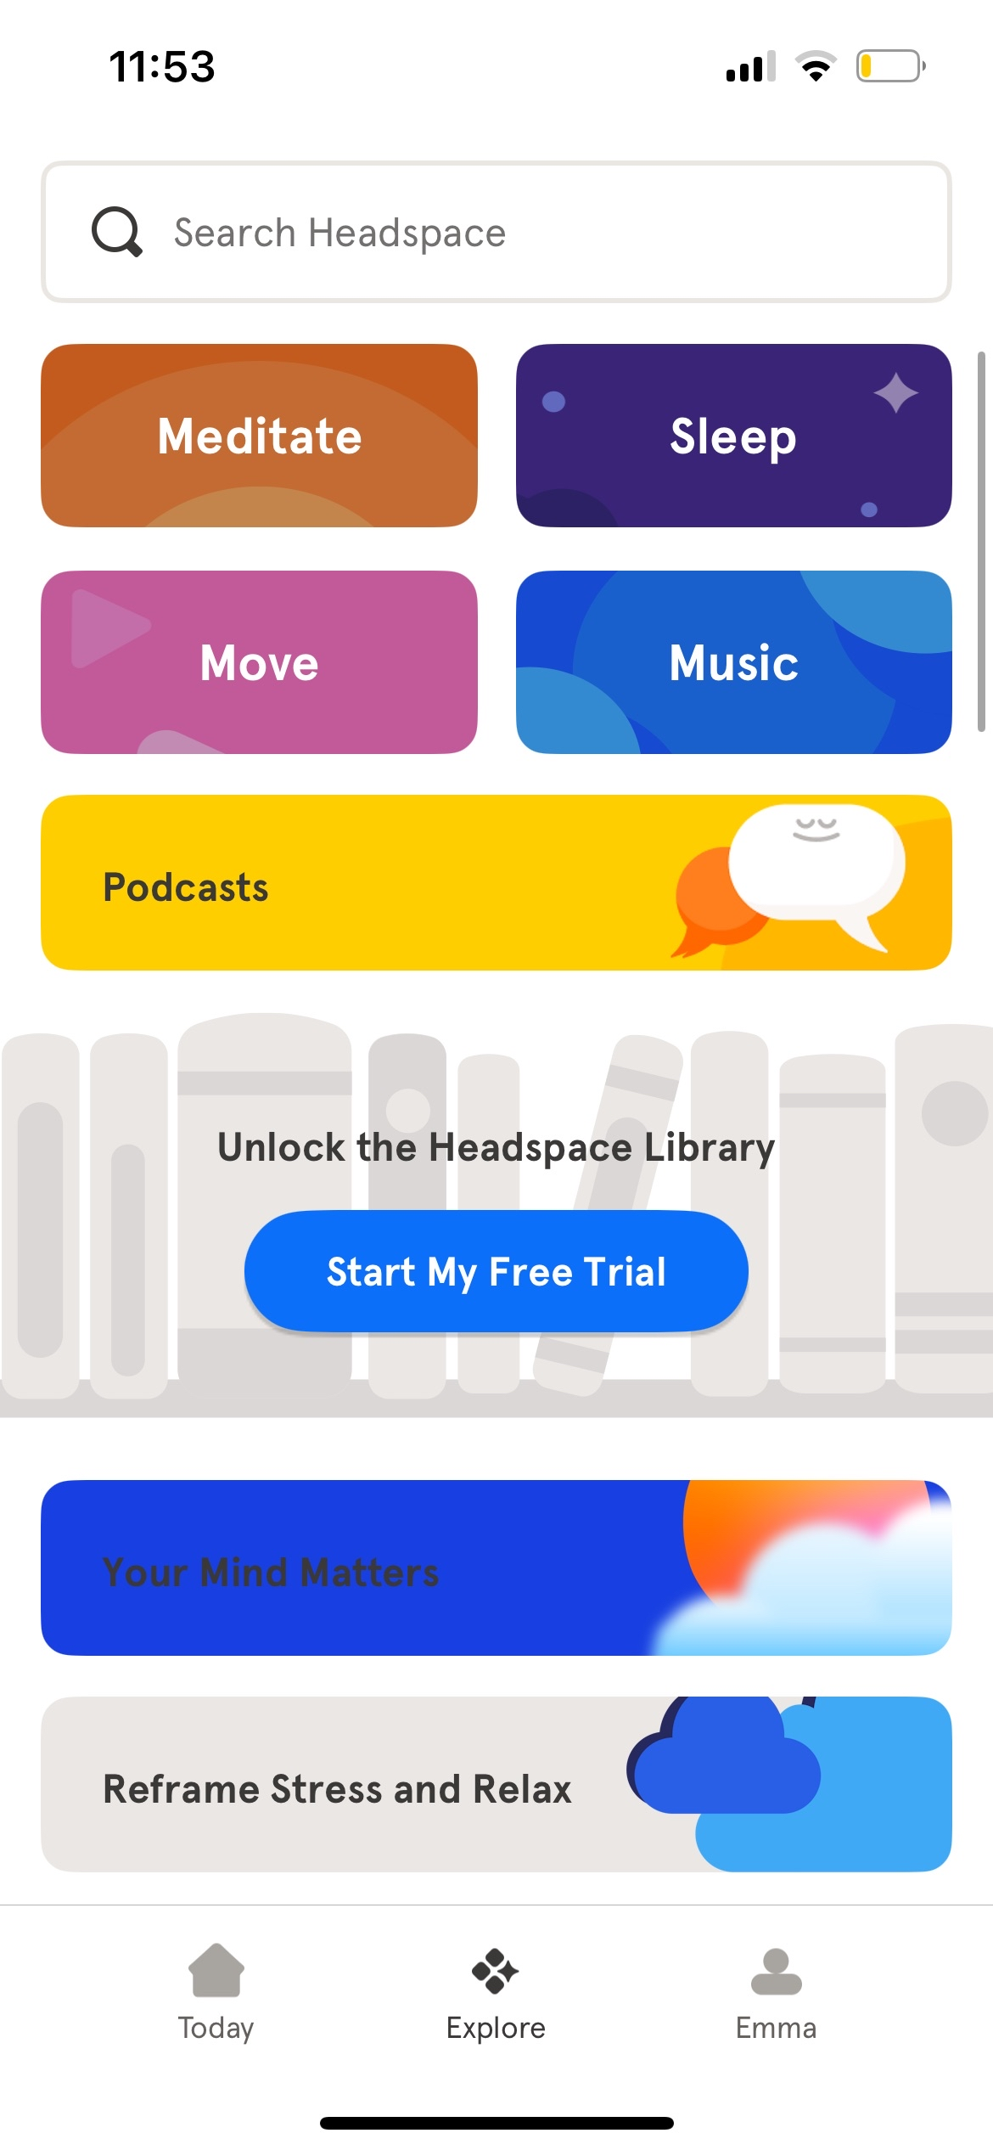

2. Finch  
I like the features on this a lot, as well as how interactive and fun it is for the user to access the app. A pet you name and take care of, good for anonymity.

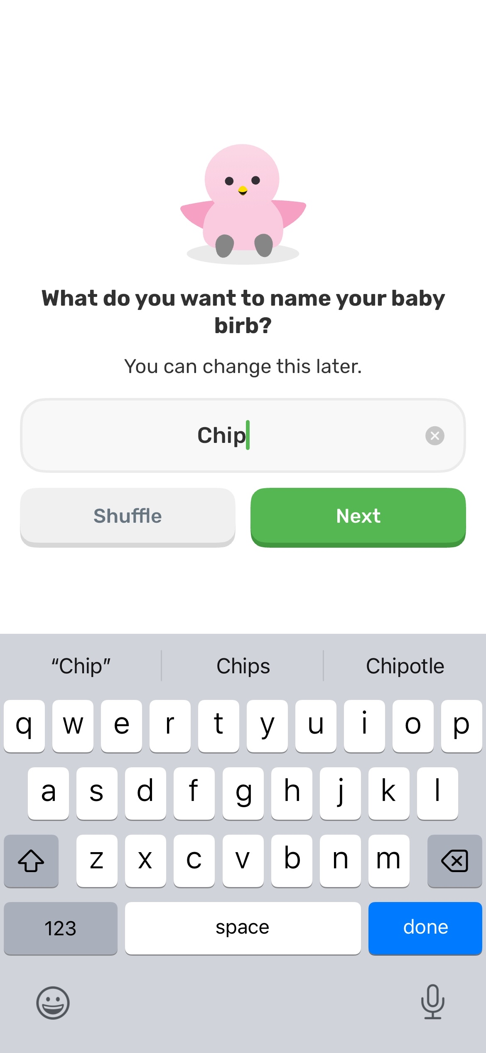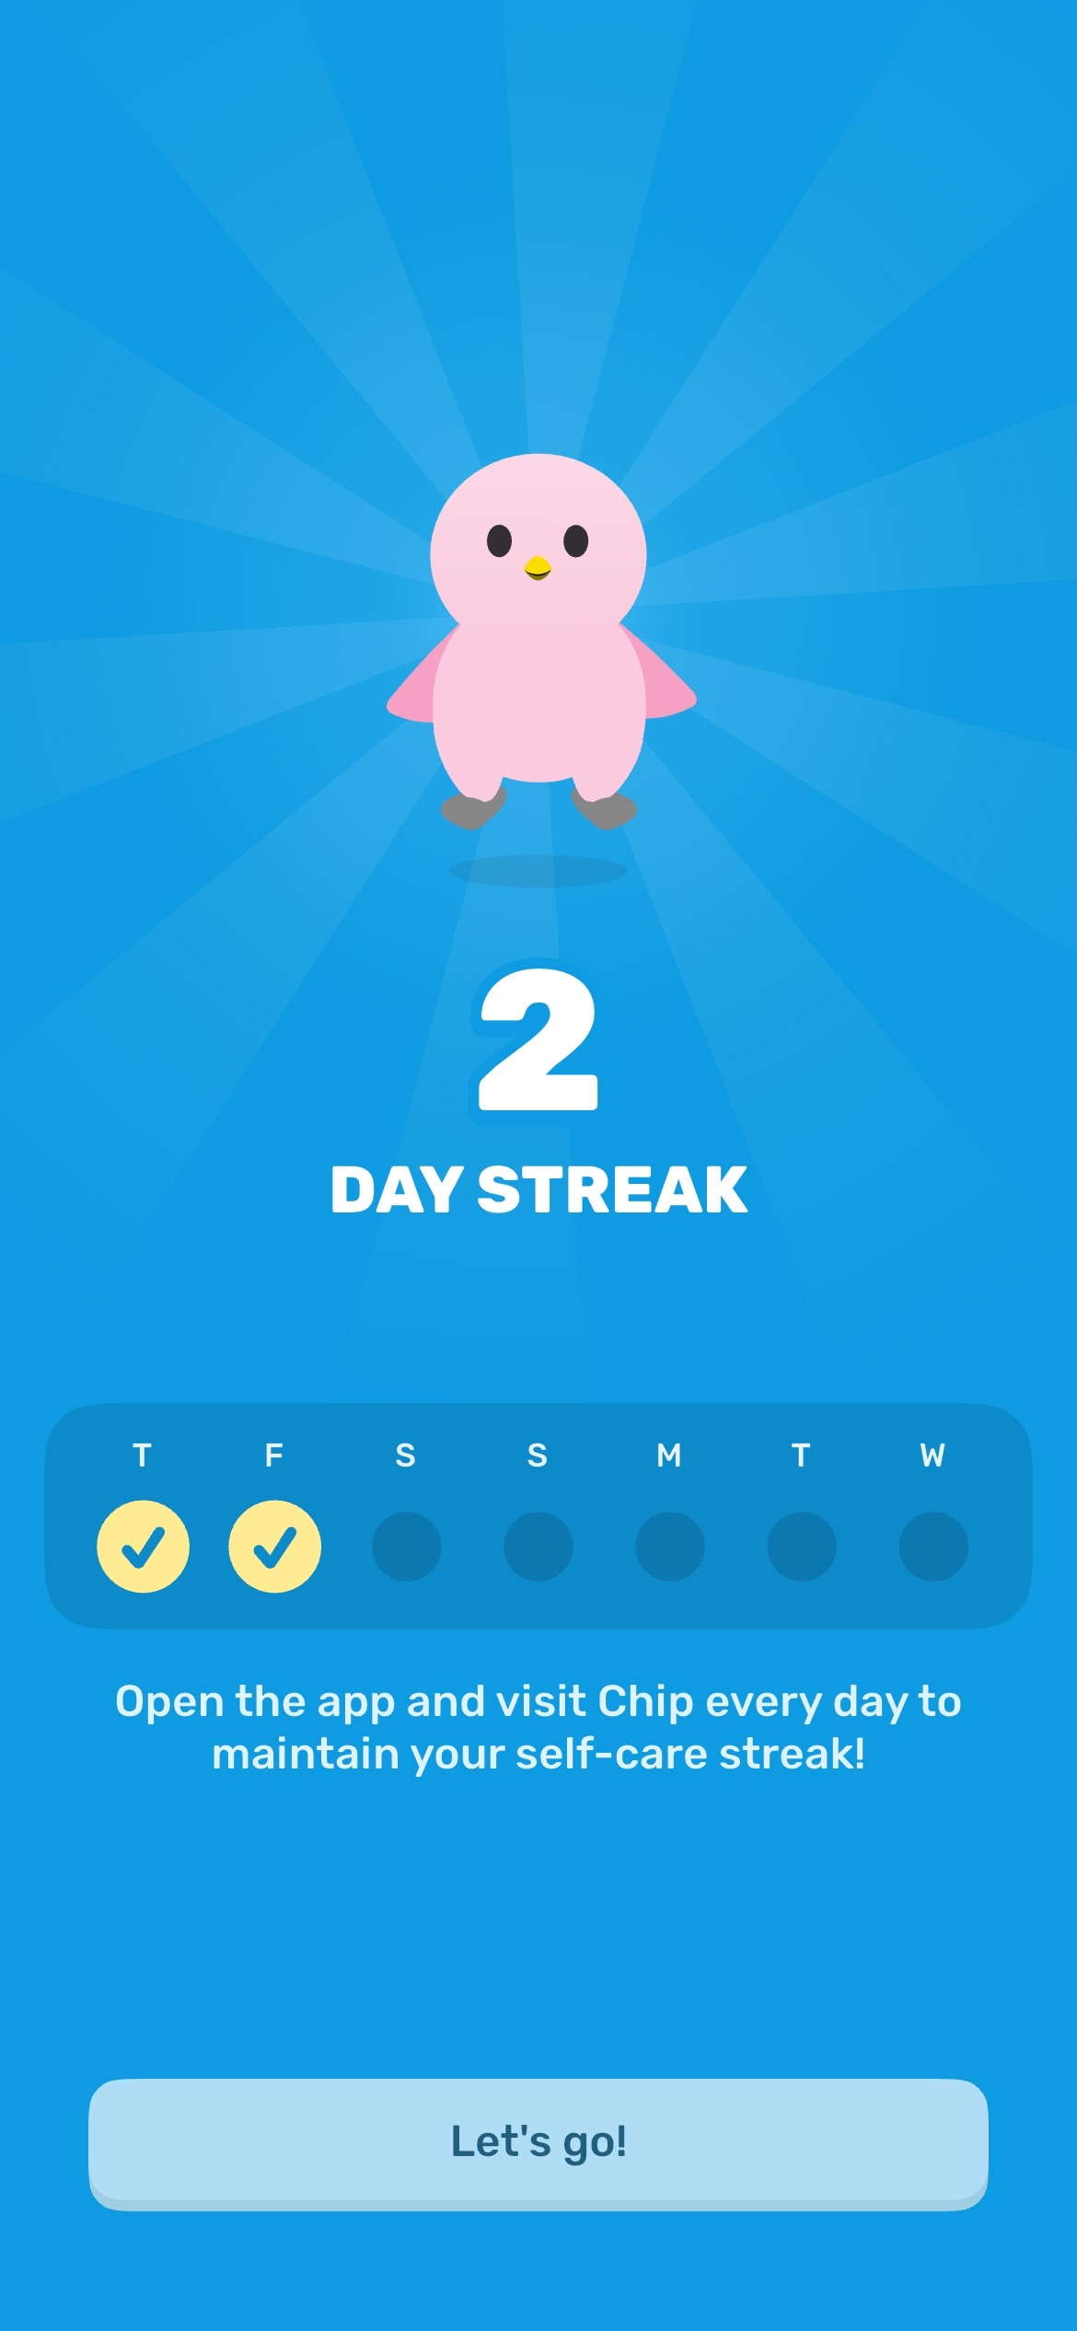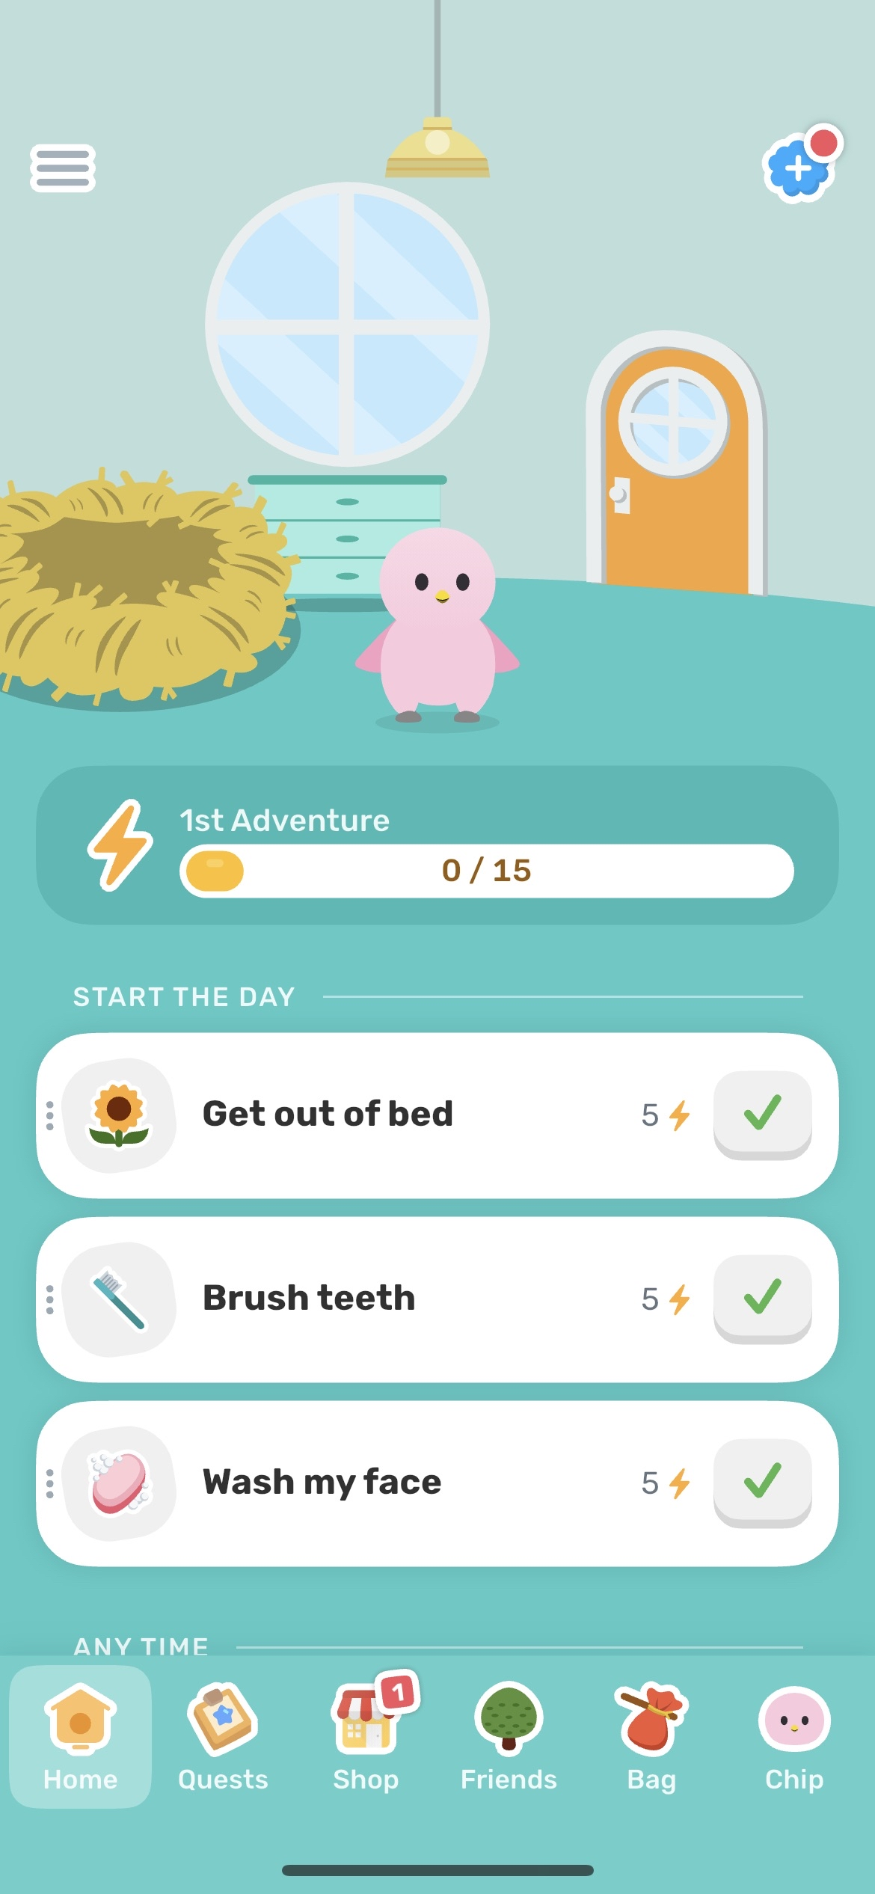

Daily Quests; keeps the user wanting to use the app more frequently, to maintain streaks, to be reminded of their goals/track their habits.  
Completing quests leads to gaining coins to buy accessories or furniture for your pet.

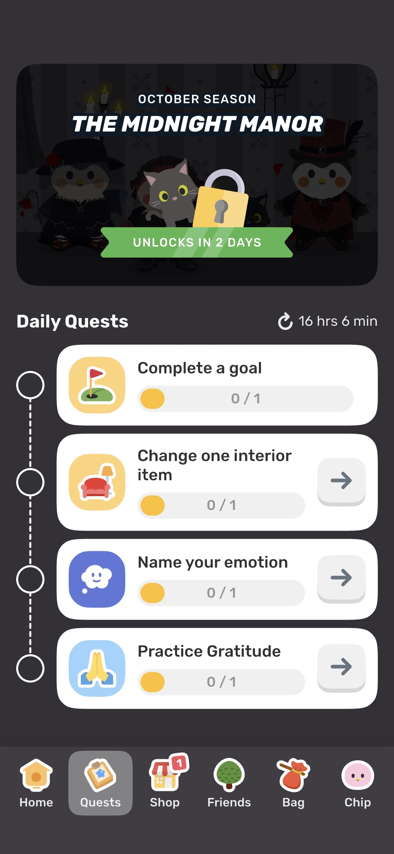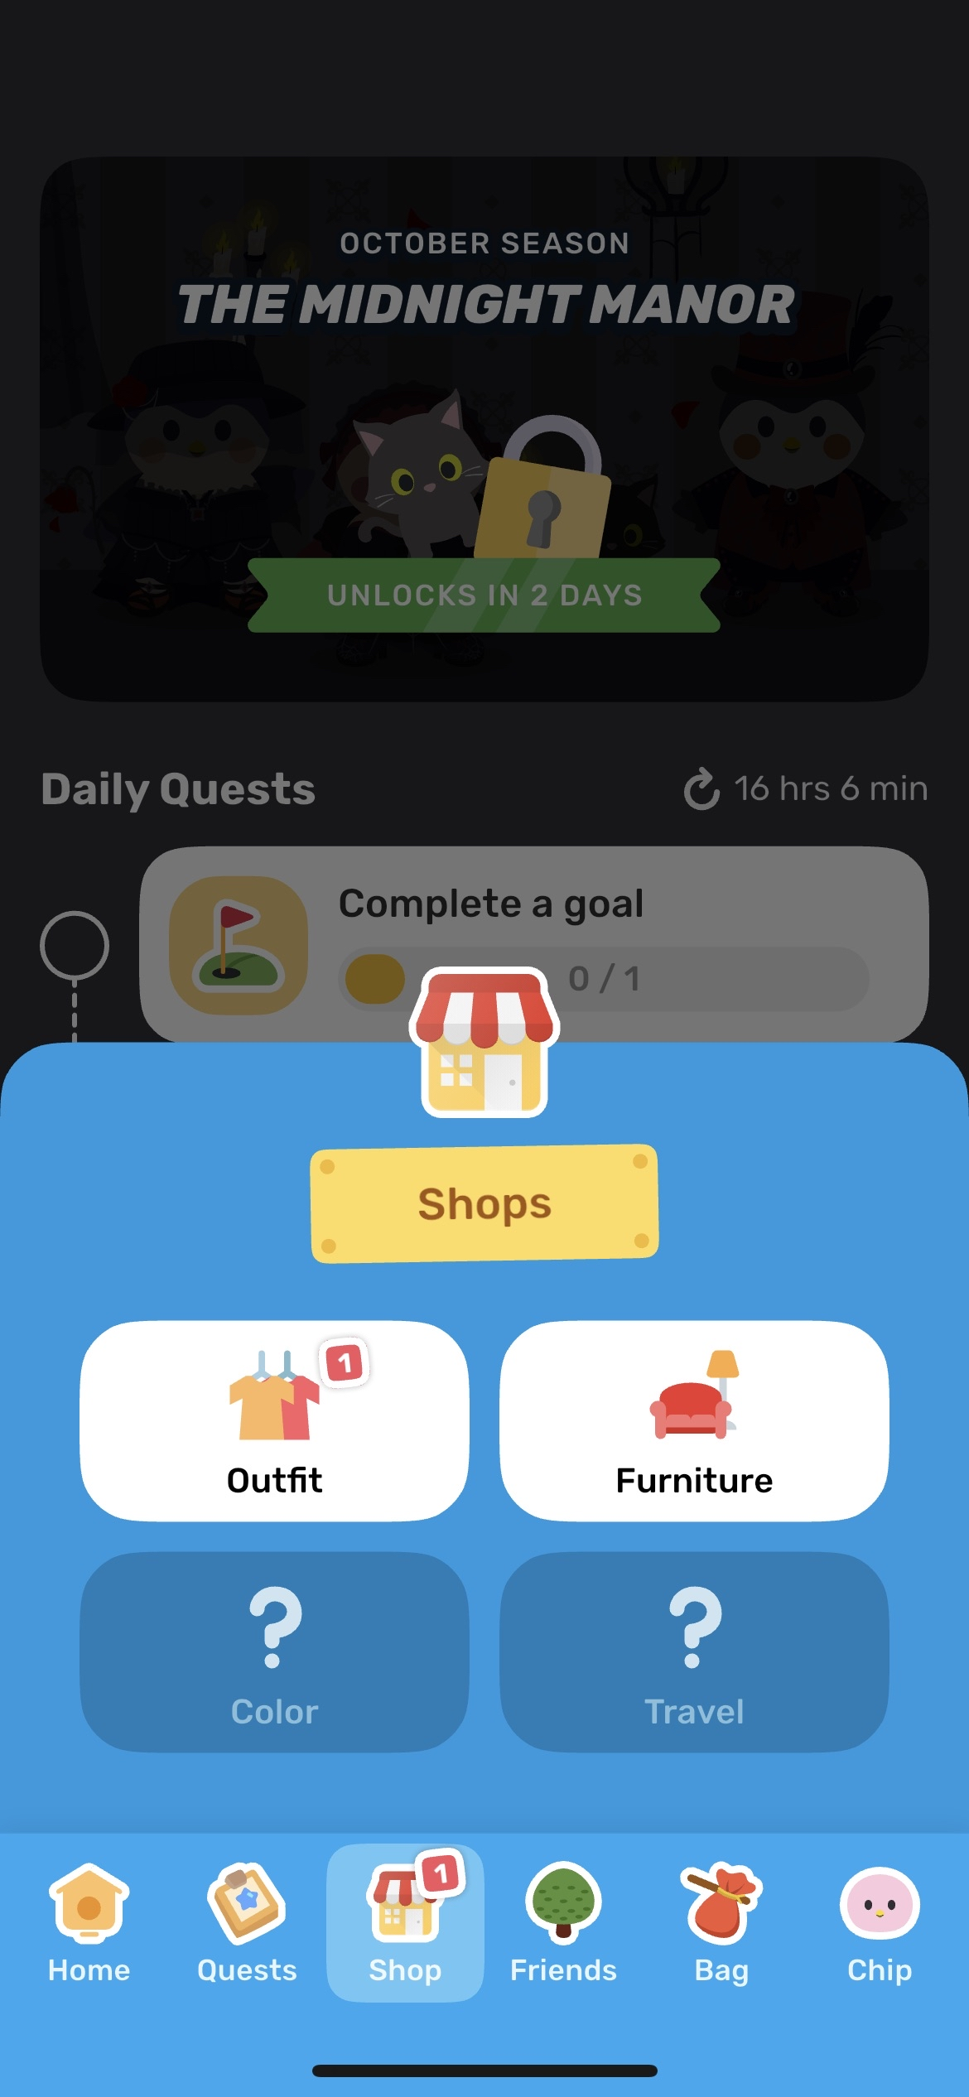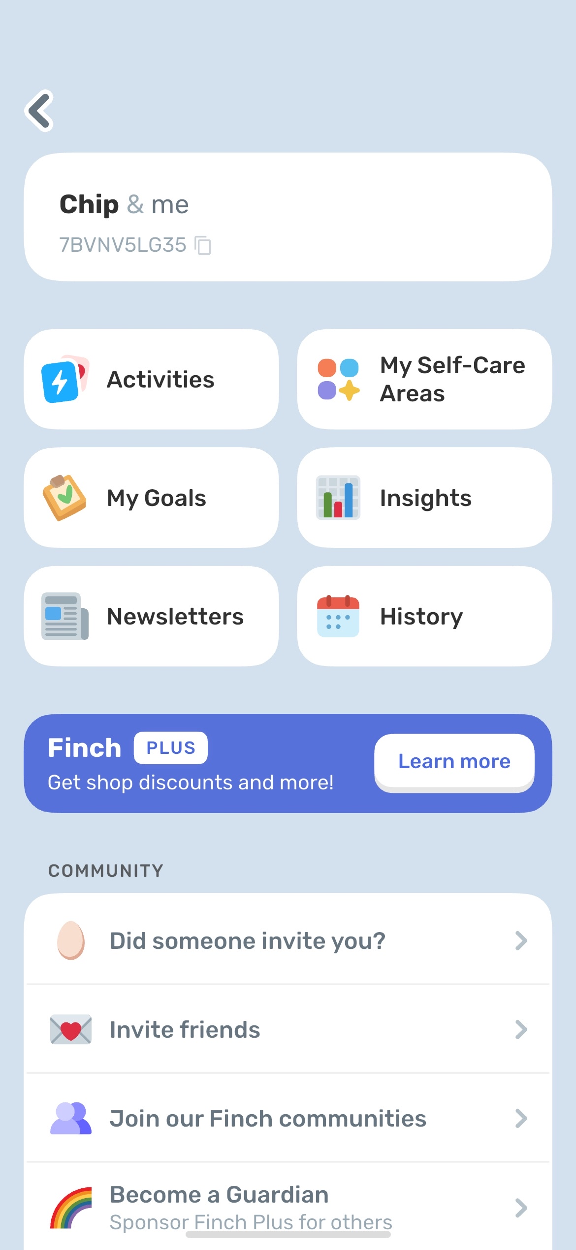

Nutrition goals/tracker; I like this idea as well, for example you can track your daily intake of water here, how many meals you’ve had or snacks.  
  
Could have a calorie/fat/sugar/protein count in these meals/drinks.  
Maybe a feature where you enter the type of meal you’ve had and then options to fill in the details of the meal,  
(i.e., an input feature where you can only enter numbers to 2 decimal places and a fixed ‘kcal’ for calories in the calories field, etc.)  
This way the use can keep a track of how much they've had daily and then can access their progress through weekly/monthly bar charts and can filter options for the different diet categories.

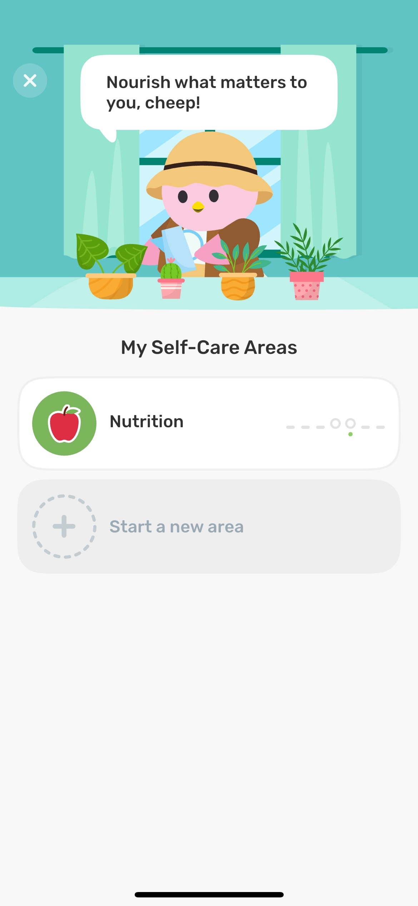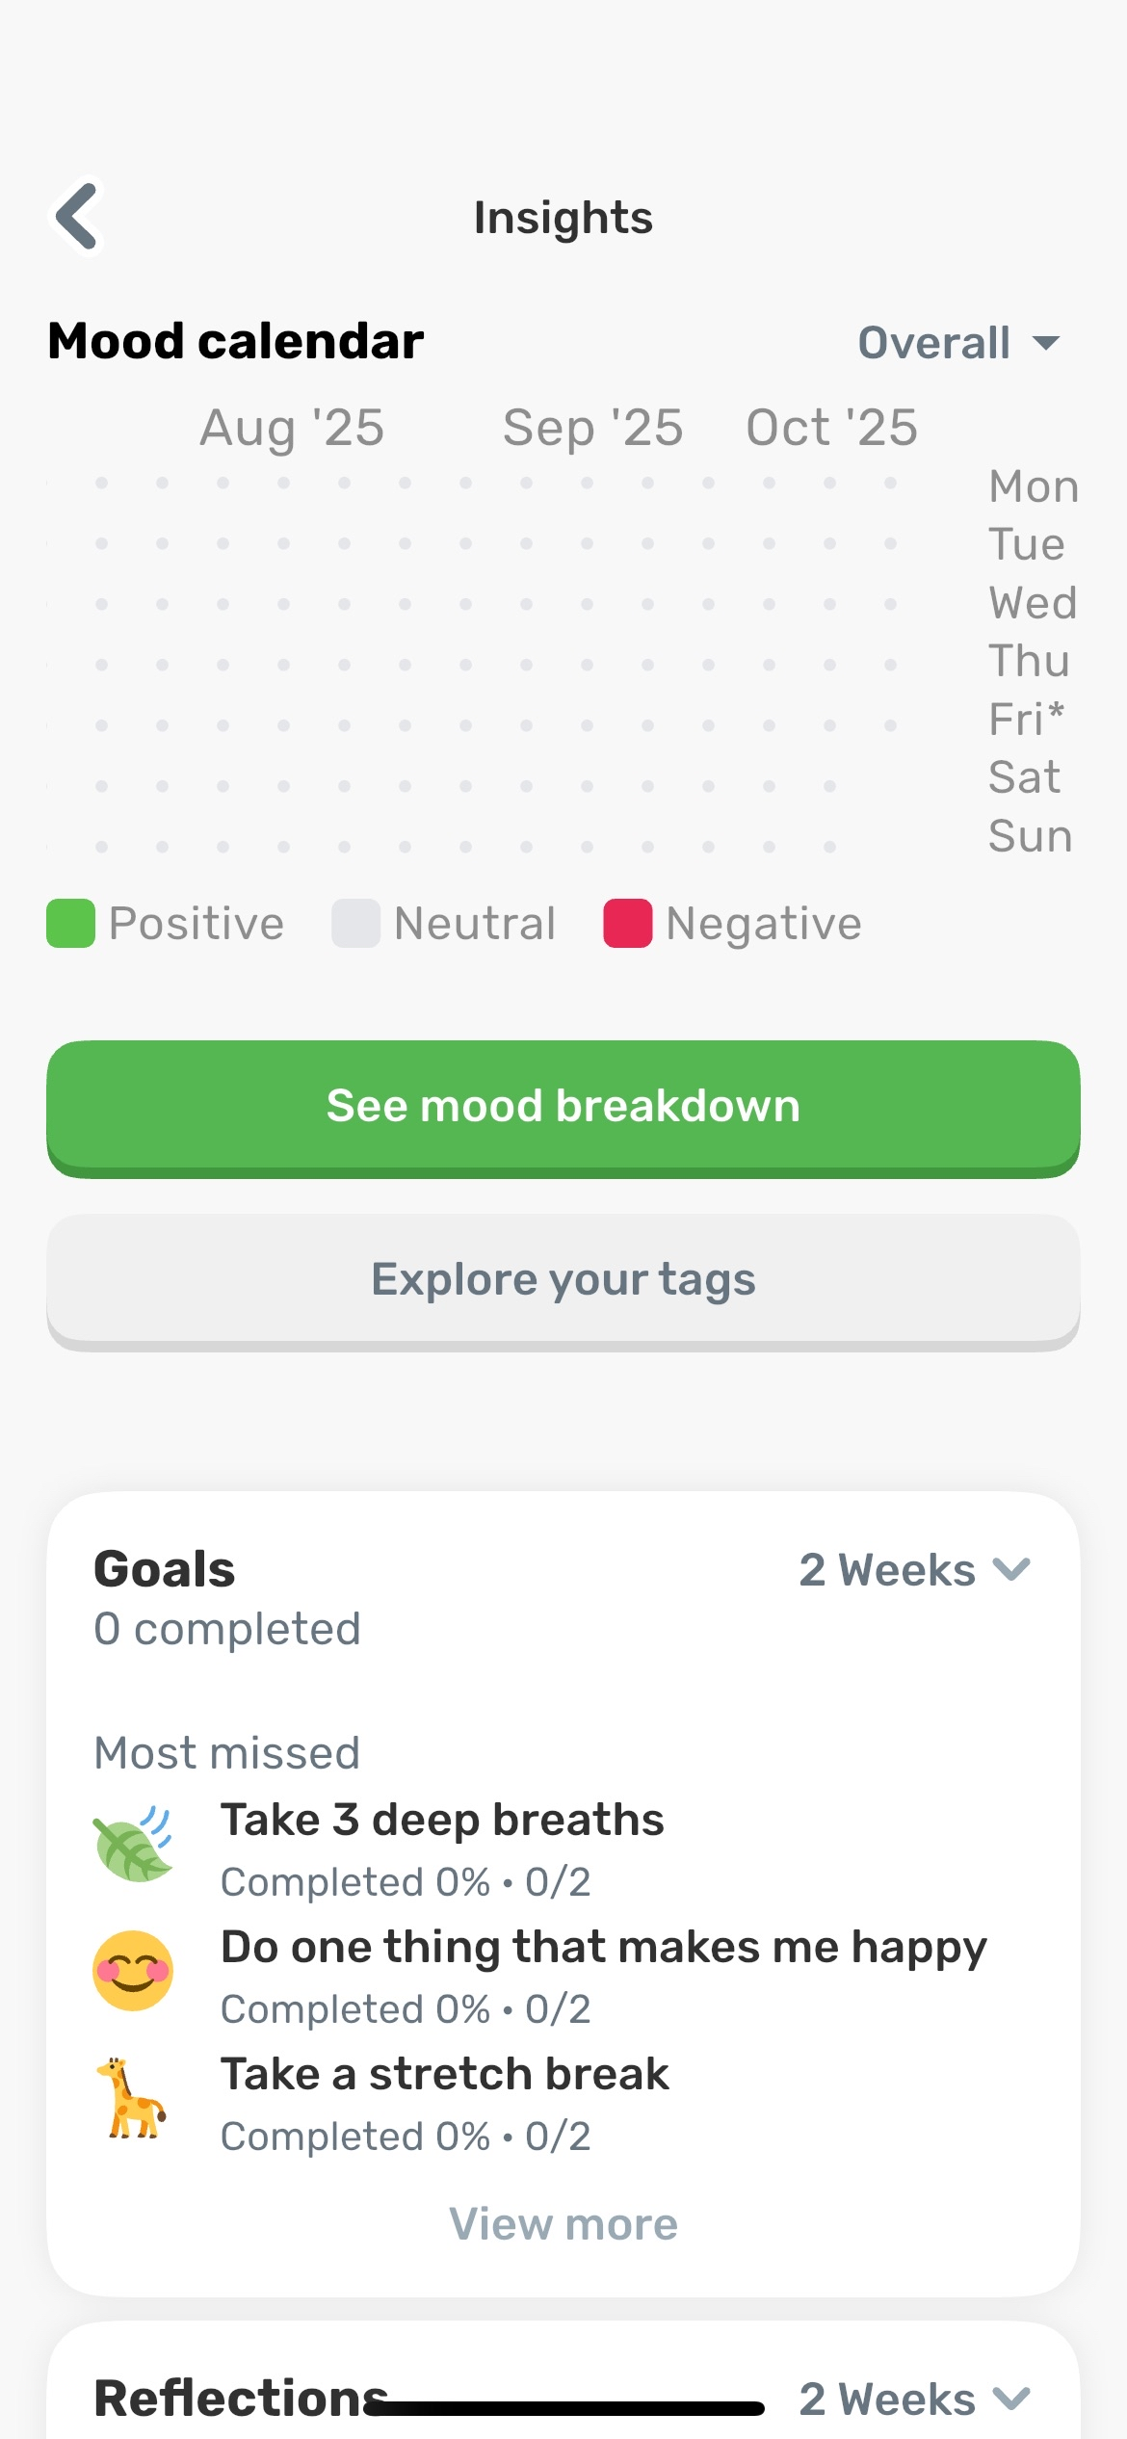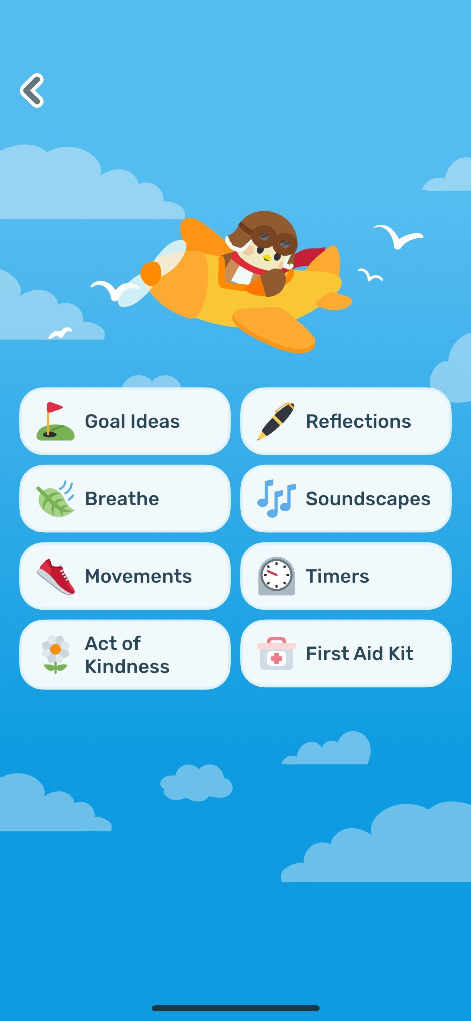

3. Daylio  
Design isn’t as appealing as the other apps

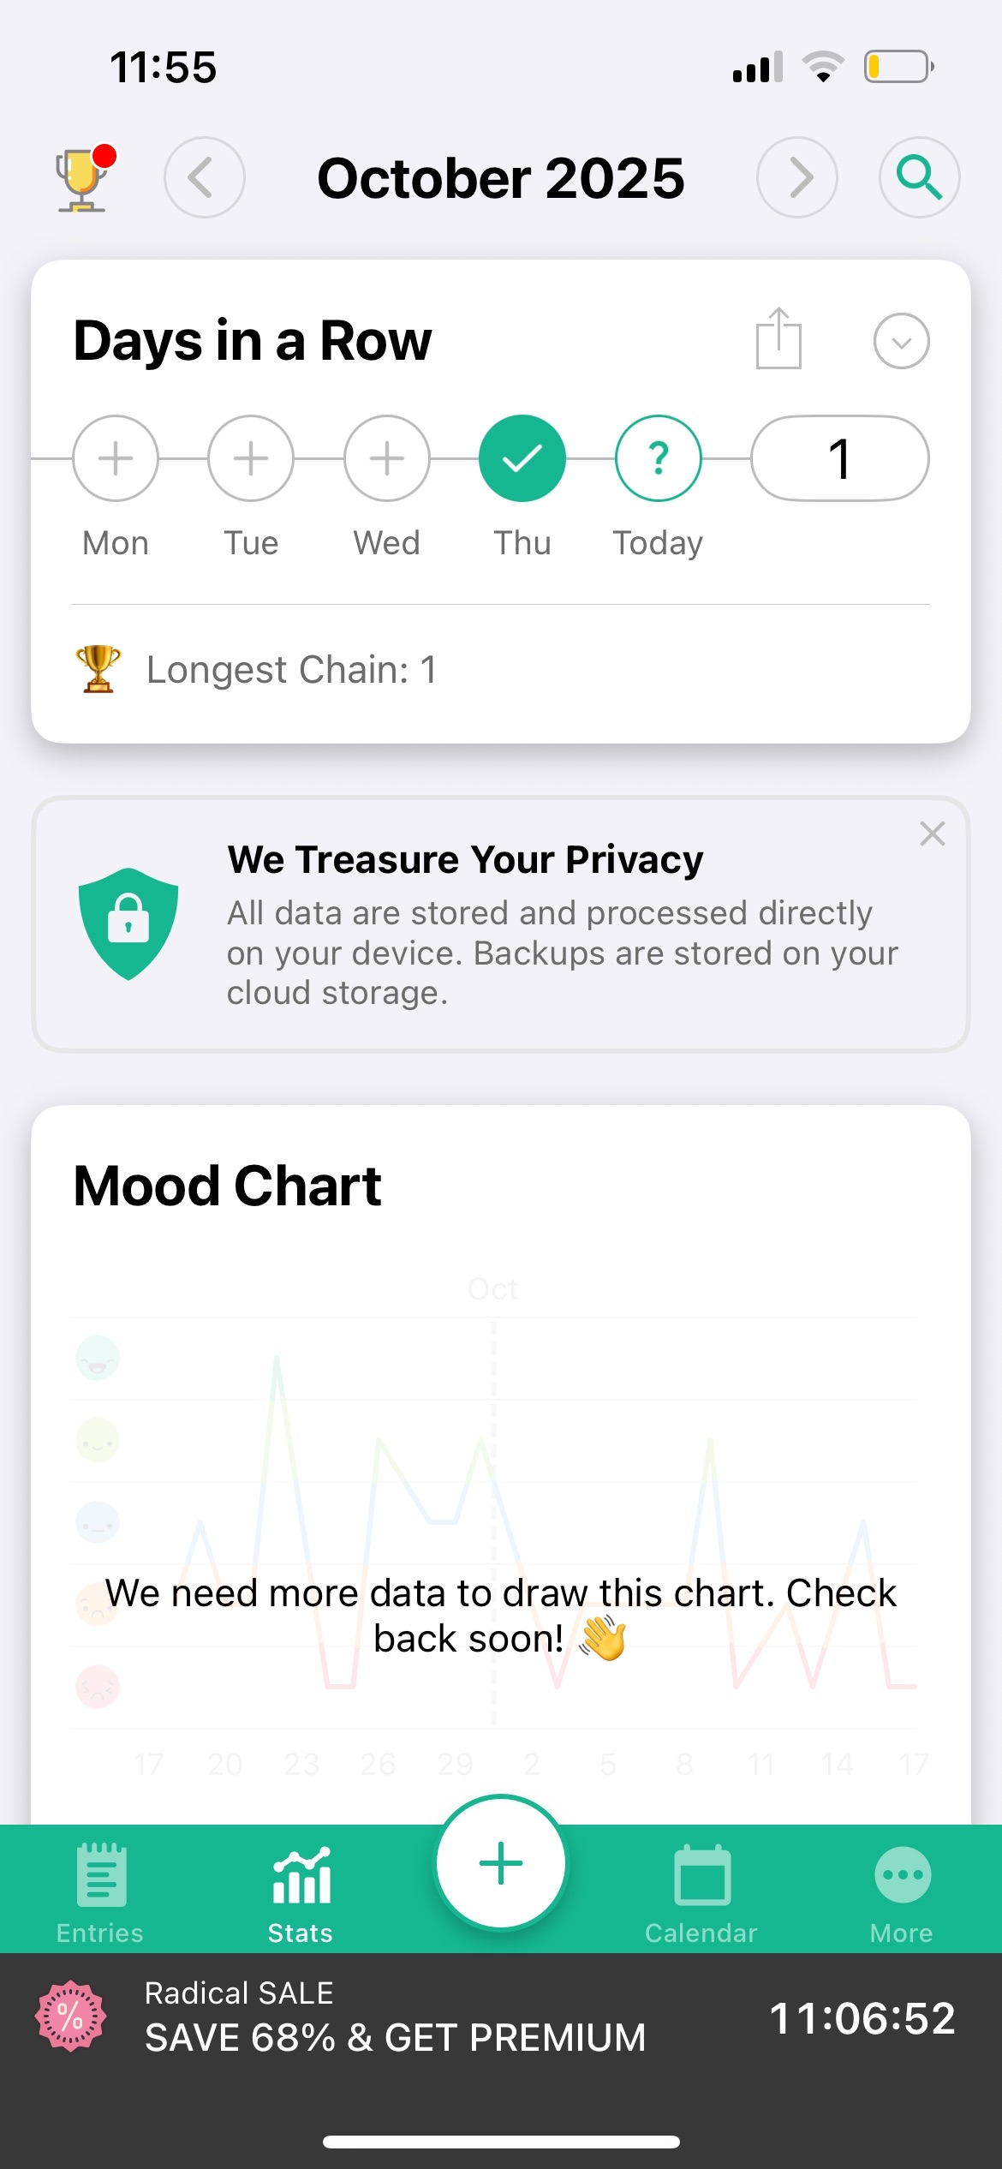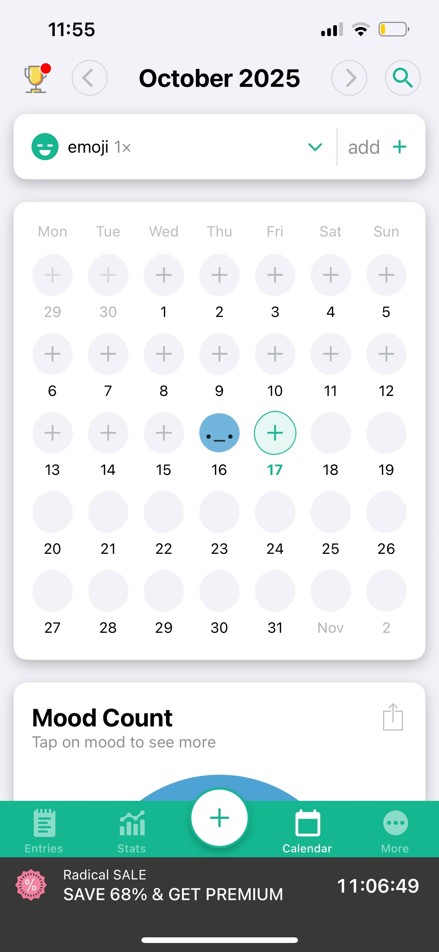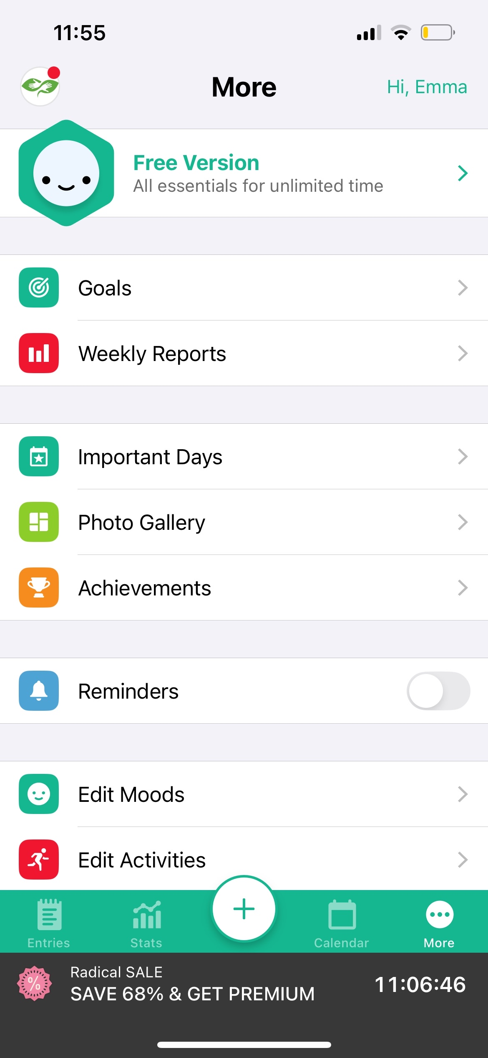

4. Mental Health Journal  
I like the features on this and the layout – box features, nice and compact  
Colourful boxes looks like sticky notes, scattered like a personal diary

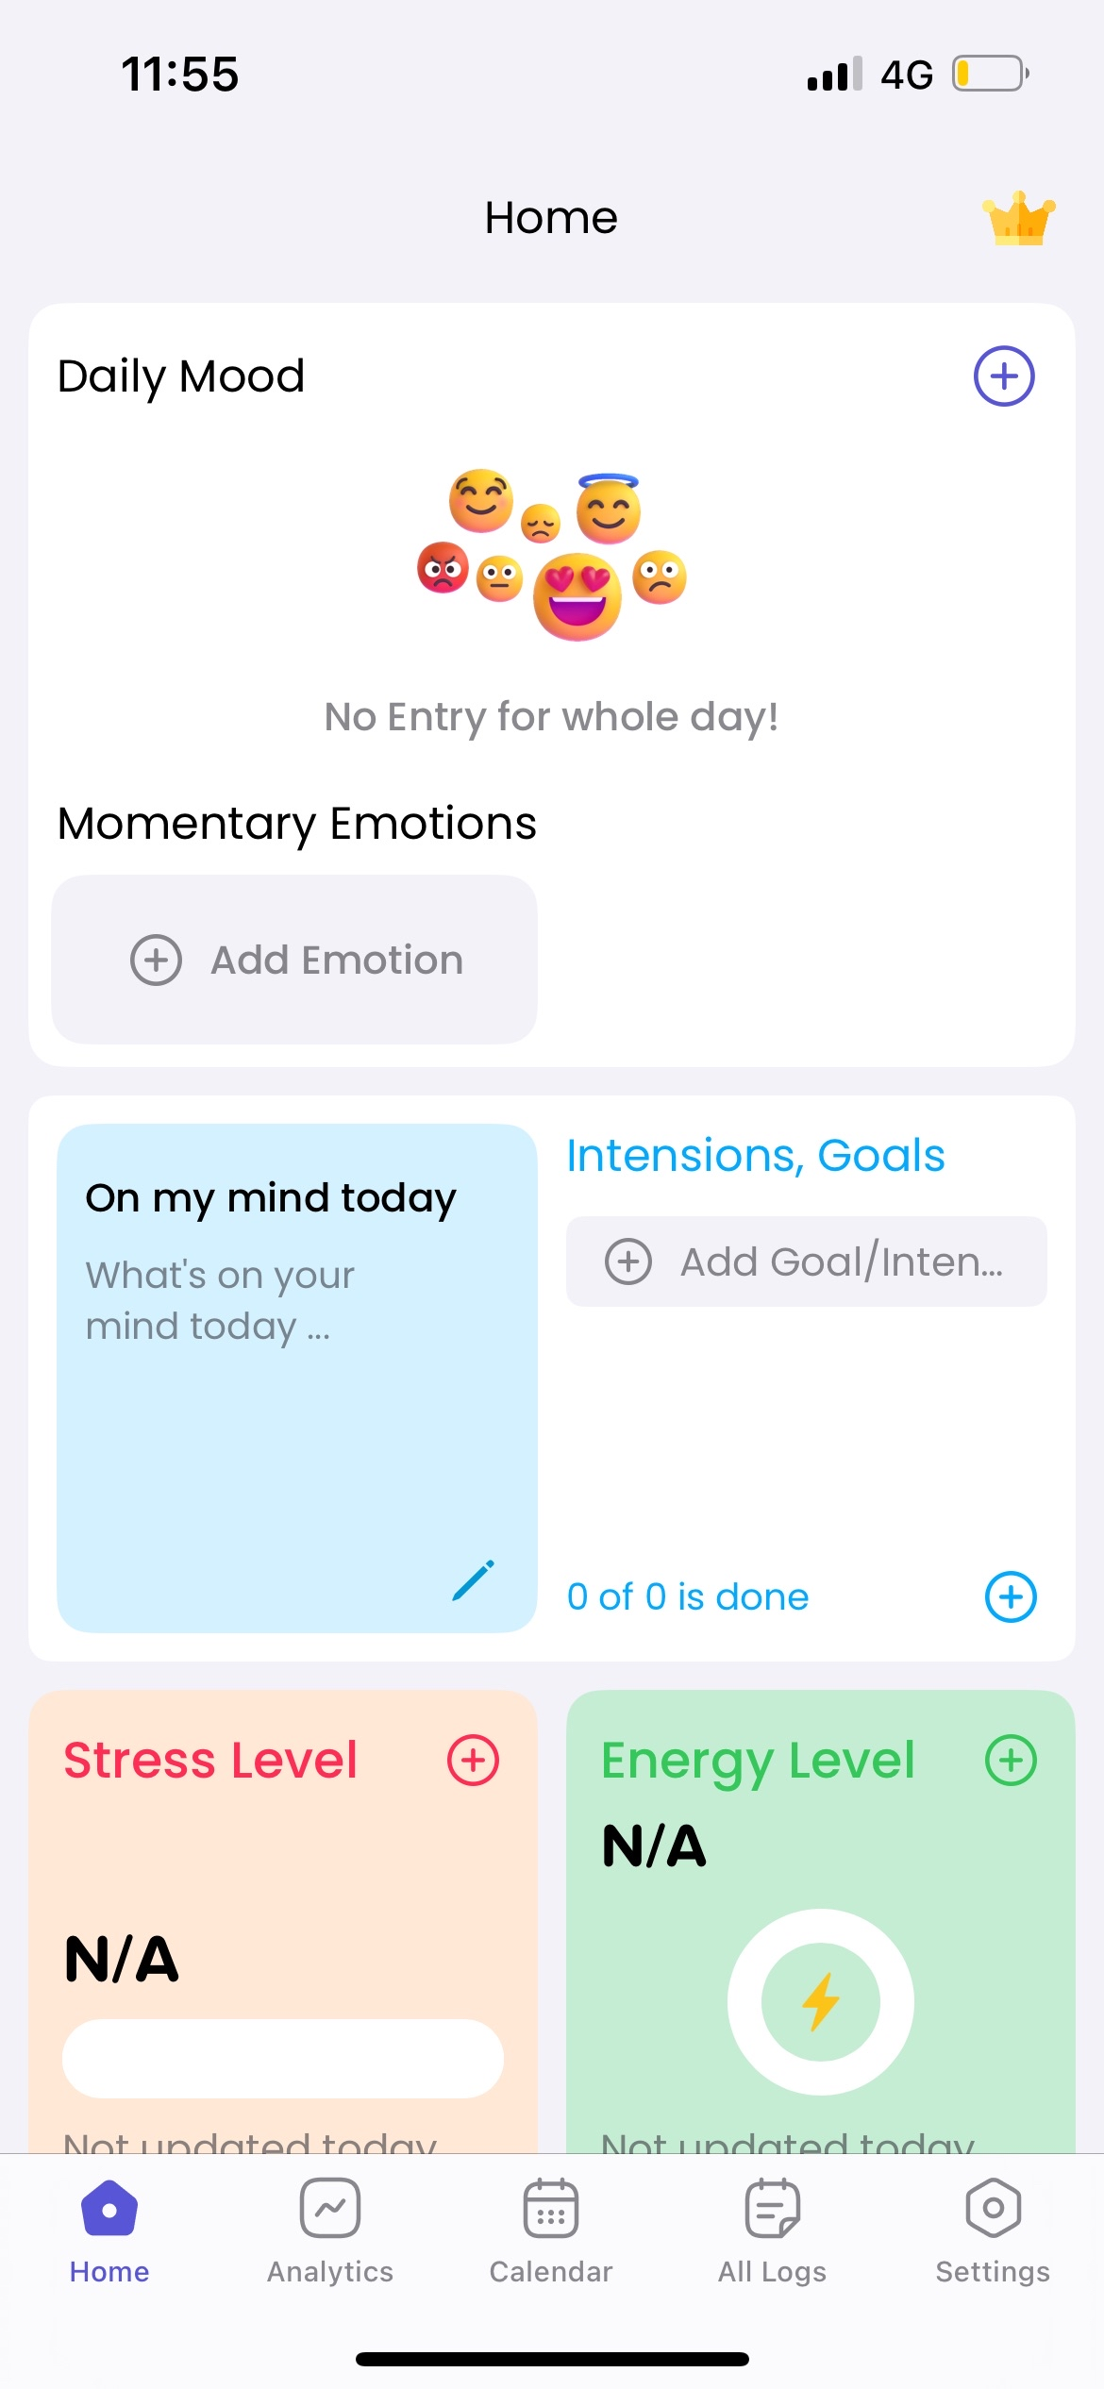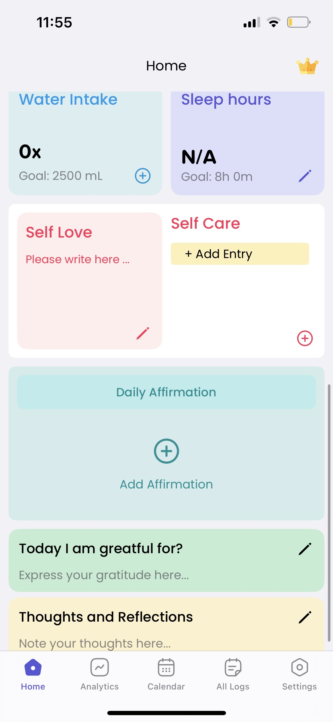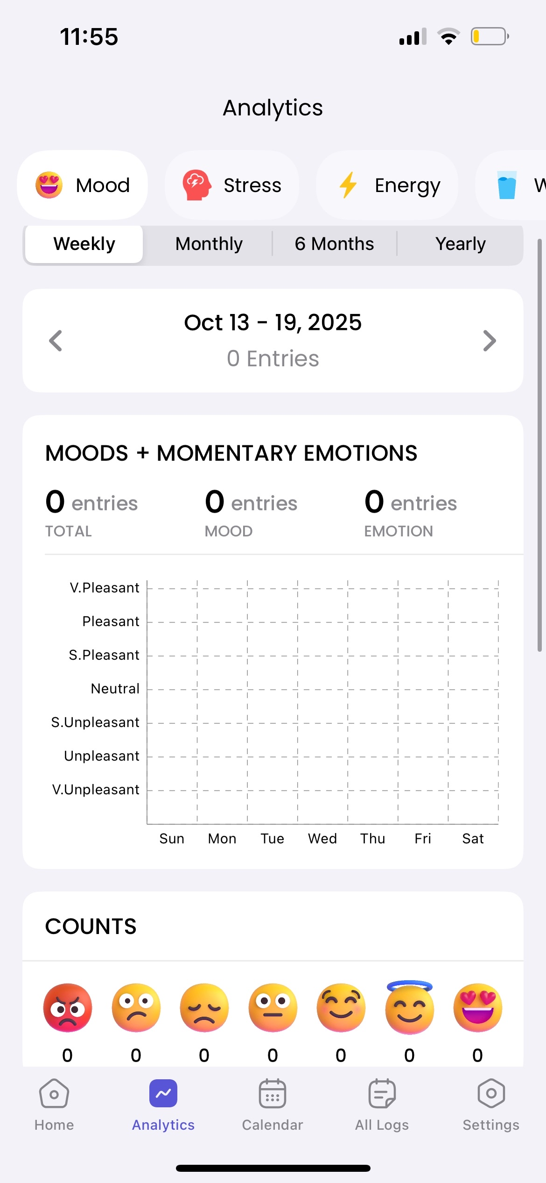

Filter through different features through the calendar, or look through all of the user’s logs  
The filters at the top are what I’d take inspiration for the nutrition categories for the bar charts from the Finch app.

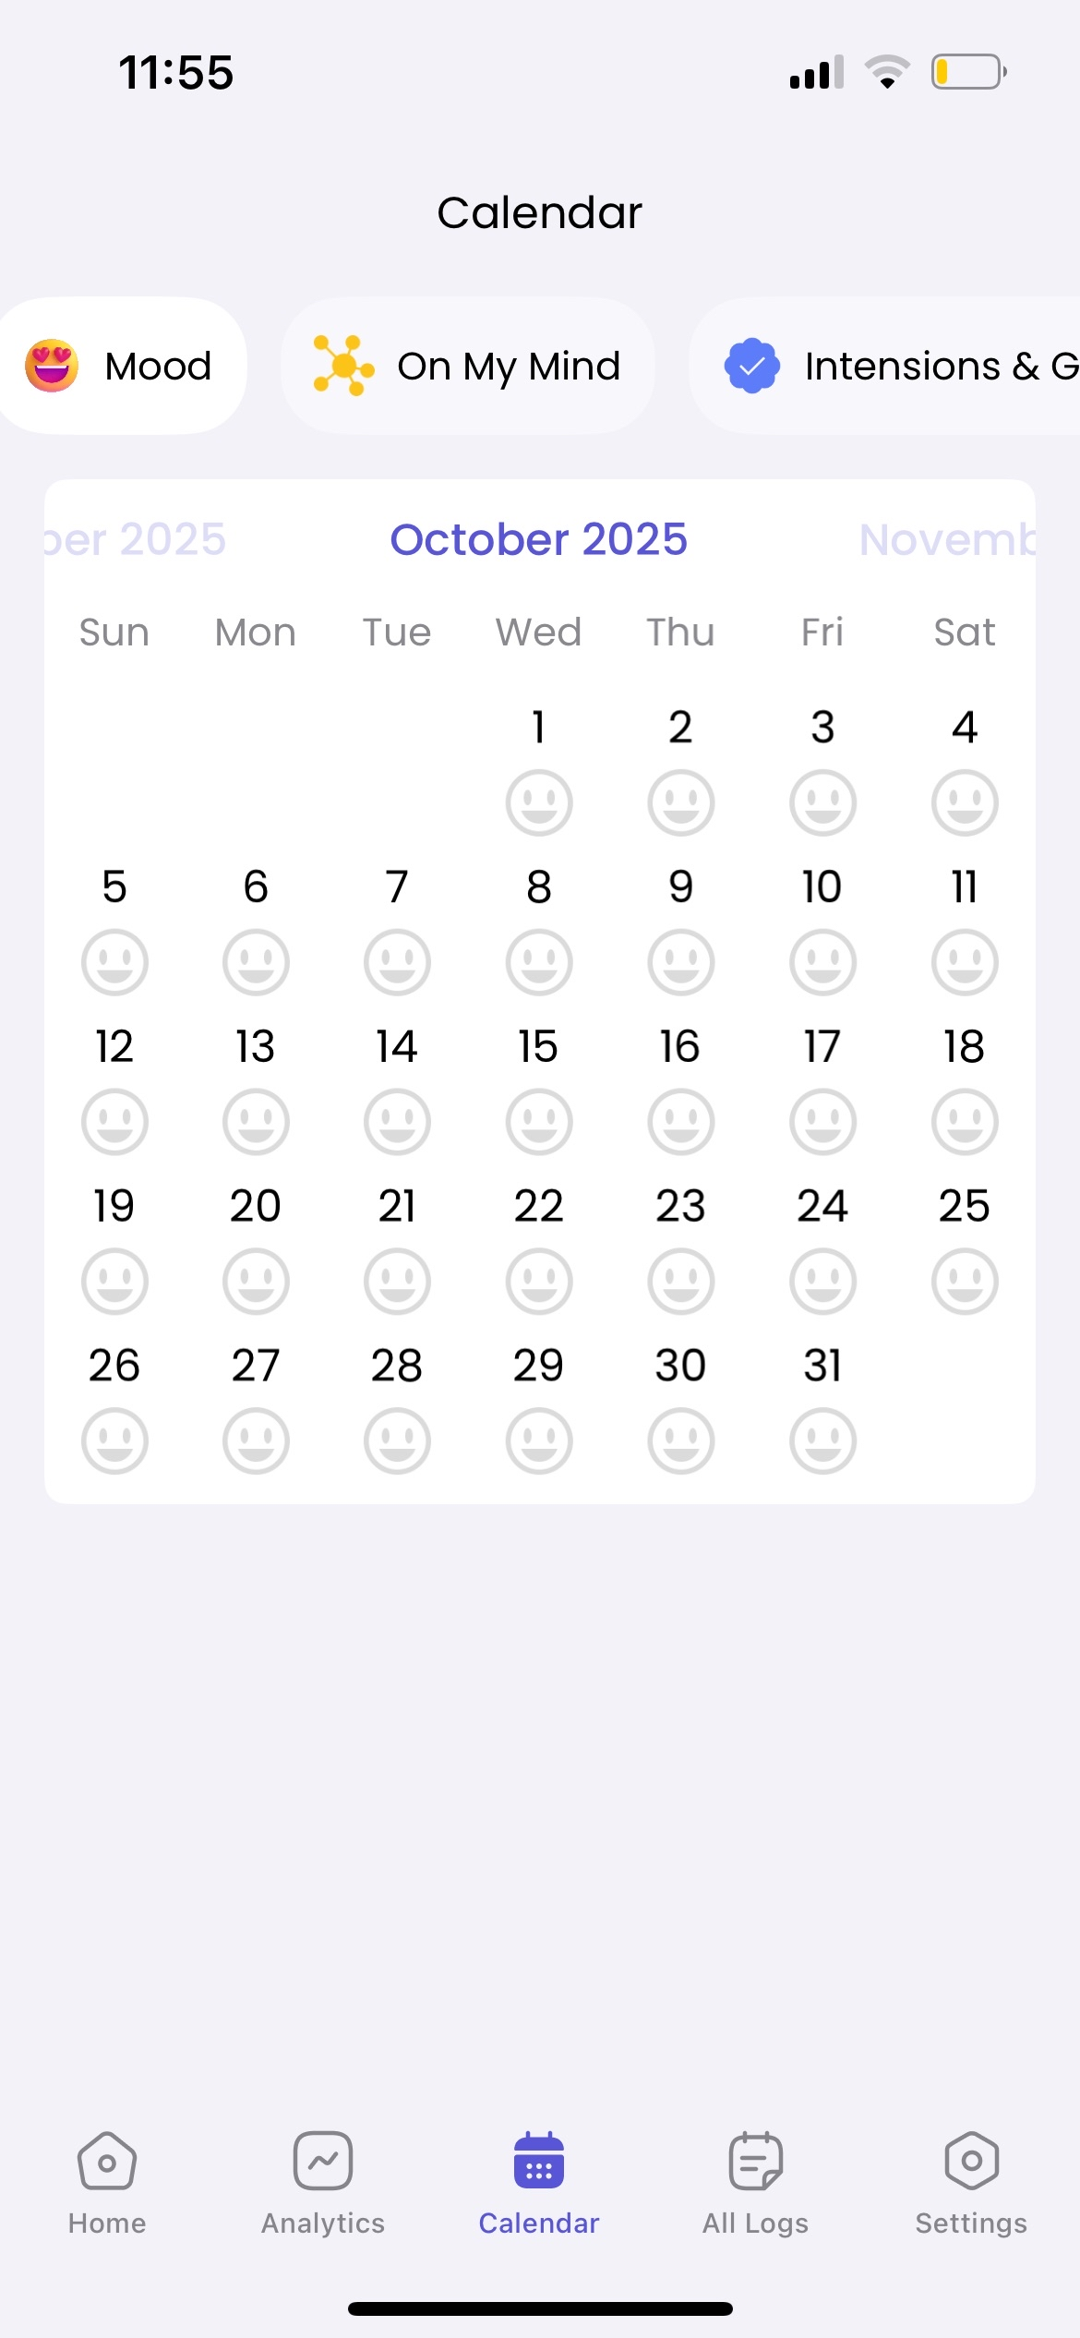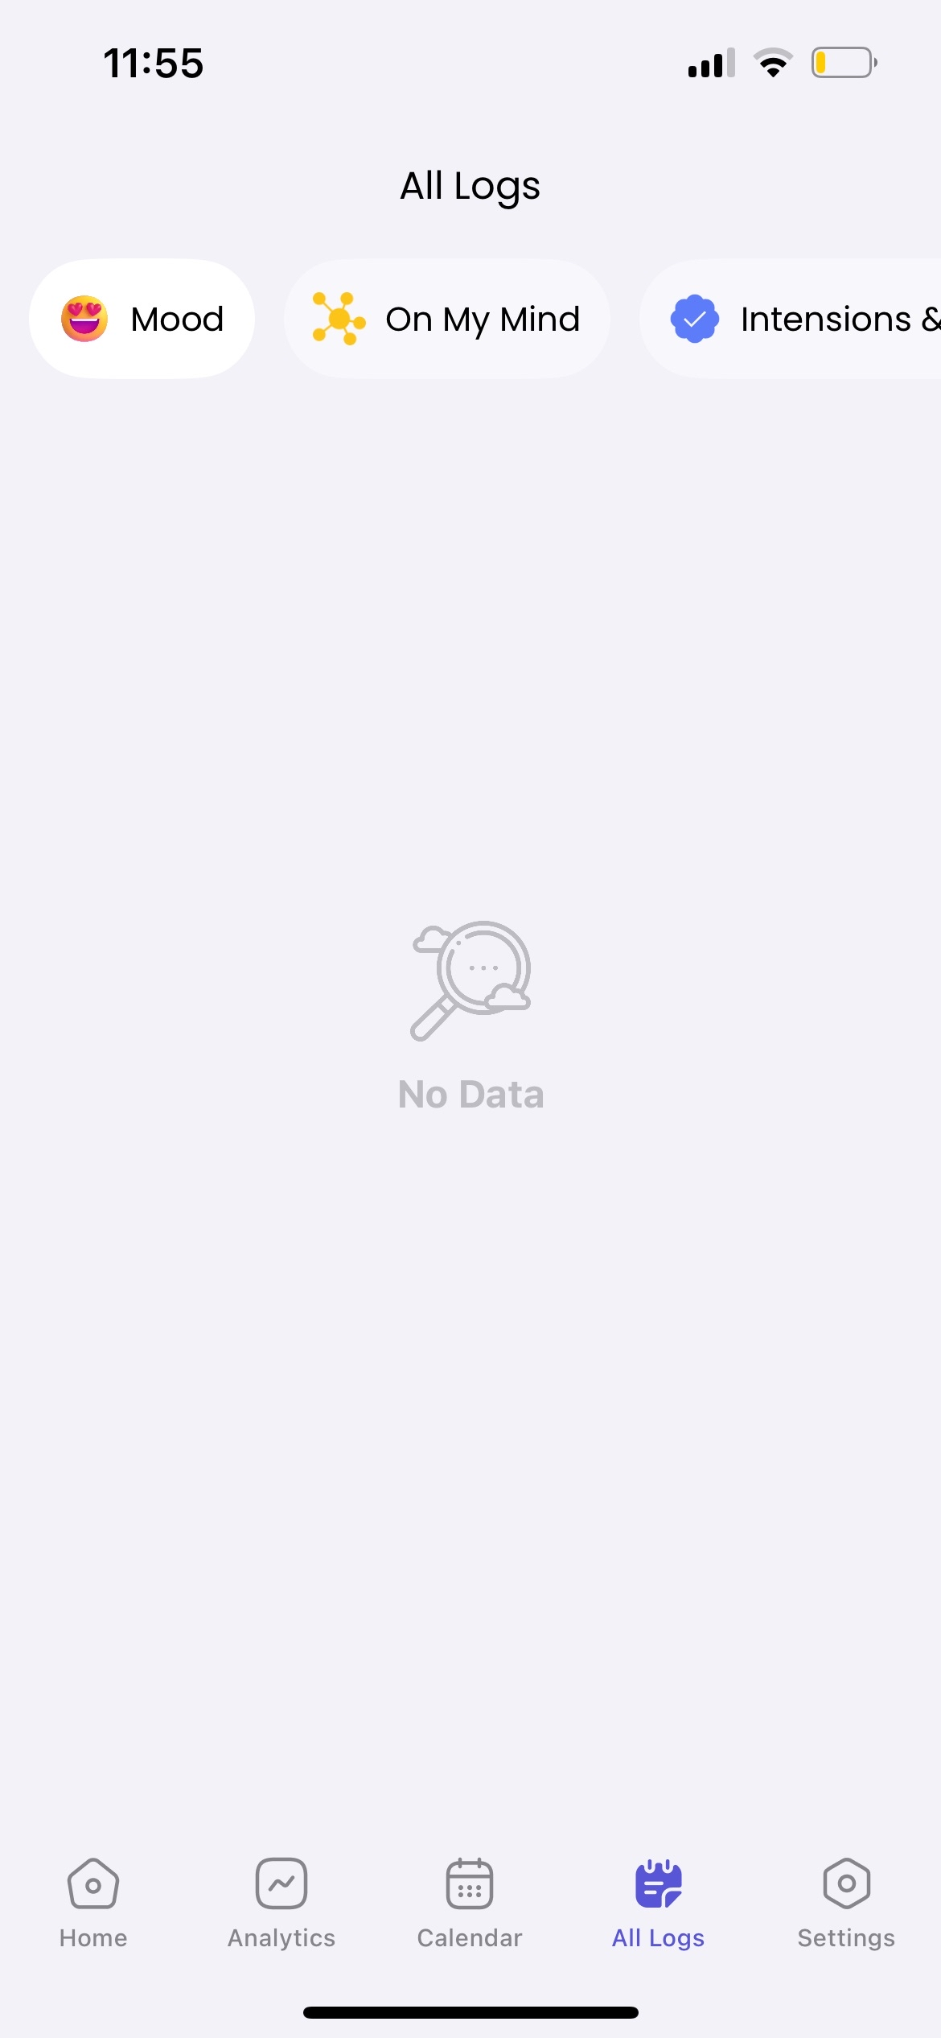

|  |  |  |  |
| --- | --- | --- | --- |
| **Headspace** | **Finch (Pet)** | **Daylio** | **Mental Health Journal** |
| Mindful Activities | Daily Goals | Mood Chart | Daily mood |
| Meditation Courses | Quests that unlock accessories for your pet or gain coins to buy in the shop | Goals | Journal |
| Podcasts | Shop feature to accessorize your pet | Important Days | Intentions/Goals |
| Sleep Music | Reflections (Journal) | Achievements | Stress levels |
| Exercise Videos | Insights – mood calender |  | Energy Levels |
| Streaks | Nutrition calendar and goals/milestones. E.g. drink at least 3 cups of water daily |  | Water Intake |
|  | Streaks with rewards for pet |  | Self Care |
|  |  |  | Sleep hours |
|  |  |  | ‘Today I am grateful for..’ |
|  |  |  | Calendar |